Main reason is to use Slack for communication tool in Organization.
In slack left side tab show Channels
- Documents – will post all documents.
- Doubts – ask your query in that channel.

- What is Jira?
Jira is ticketing tool.
- How to create ticket in Jira?
Click on Create button-select project - issue type – select Status -- type summary -- type description – select reporter – select Assignee—select Priority – click on create button
- How to change ticket status?
All ticket is show on user’s dashboard –open ticket—you get all info about ticket description, Assignee and Reporter.

You will see the backlog dropdown. Select value to InProgress –type comment.
Ticket is start with status of Backlog, In Progress and Done

- We will cover below tools
Linux, Git, GitHub, Jenkins, Maven, SonarQube, Nexus, Ansible, Docker, Terraform, Kubernetes, AWS Cloud.

- What is Devops ?
Dev = Development
Ops = Operations
- What is release?
Release means version of software or Mobile application.

- Before devops?

Waterfall Model- The Waterfall Model is a linear and sequential software development model where each phase must be completed before the next phase begins. Once a phase is finished, you usually don’t go back.

Waterfall Model: No communication between client and developer
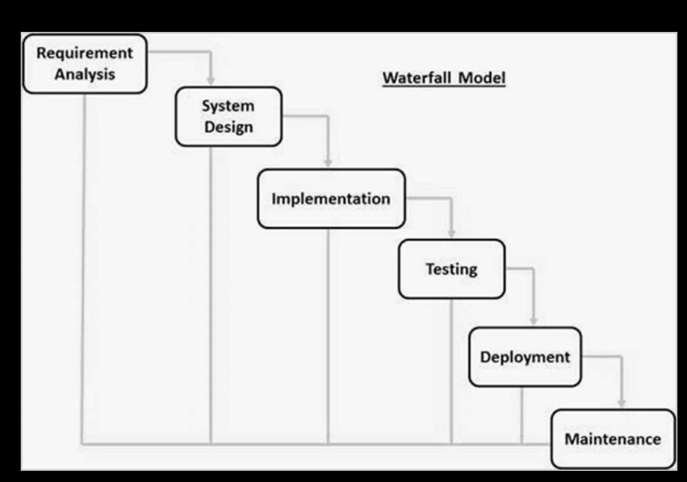
Agile Model – The entire process of building a software is broken down into small actionable blocks called sprints.

Agile Model: No communication between developer and Operation team.
That’s why DevOps use.

- What is DevOps?
DevOps is an evolution from Agile model of Software development.
Agile Addressed the gap between Clients and developers.
DevOps addressed the gap between Developer & Operation team.

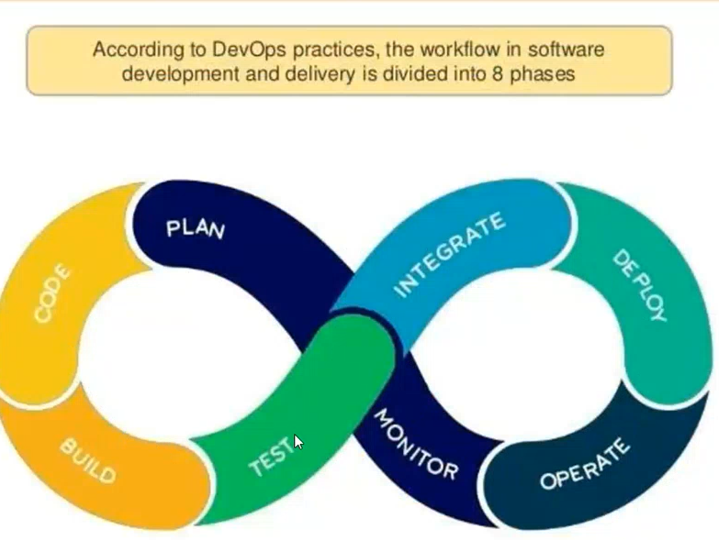
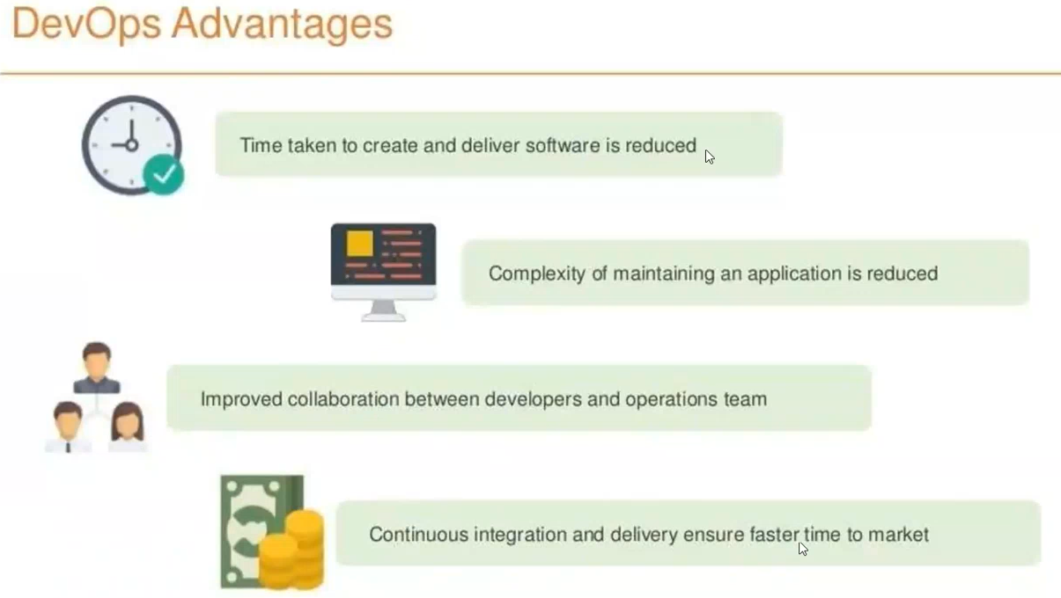

Video 2 notes.
Client-Server Architecture:
Client: Which requests a resource
Server: Which respond to the request.

Different Types of Architecture
- 1-Tier Architecture
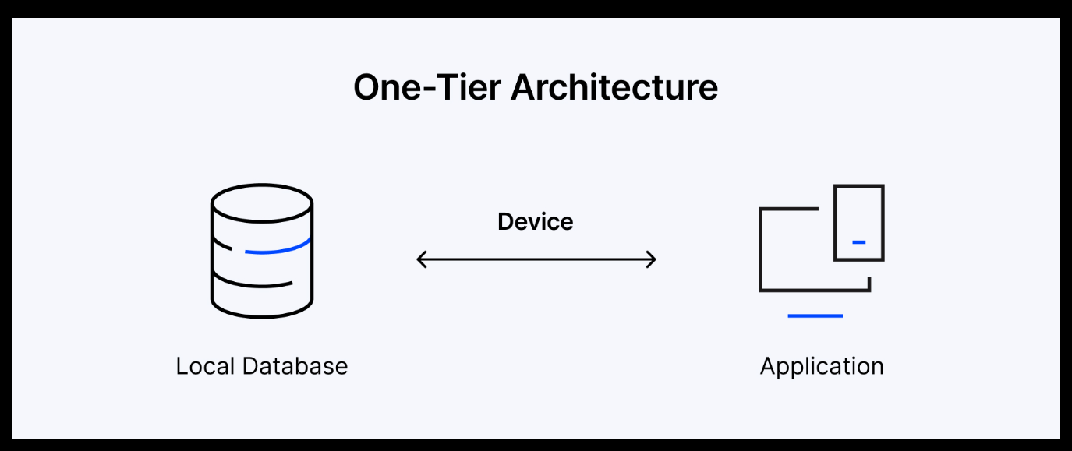
Defination: All components (UI + Business Logic + Database) are in one system
Example: Desktop apps (MS Access, old accounting software)
Advantage: Simple to Build and No network required.
Disadvantage: Not Scalable, Not Secure and Hard to Maintain.

- 2-Tier Architecture
Definition: The application is divided into client (UI) and server (database).
Example: Desktop app connected to a database server (MySQL, SQL Server)

- 3-Tier Architecture
Definition: Application is divided into three layers:
Presentation Layer (UI)
Application Layer (Business Logic)
Data Layer (Database)
Example: Web applications (browser → backend server → database)

- N-Tier Architecture
Definition: An extension of 3-tier architecture with multiple layers/services.
Example Layers:
- Presentation Layer
- API Layer
- Business Logic Layer
- Service Layer
- Data Layer
- Cache Layer
Example: Modern cloud apps using microservices

Types of Environments:
- Development
- Staging Environment
- Production Environment also called as Live Environment.

Communicating between Client & Server using IP Address.
IP means Internet Protocol
Ipv4: use ip is (192.168.0.0)
Ipv6: use Location (2001:0db8:85a3:0000:0000:8a2e: 0370:7334)

HostName: Name of the server
Webserver: Used for static Content Deployment
Ex: Apache (httpd), nginx

Application server: Used for dynamic content Deployment
Ex: Weblogic, Apache tomcat, Jboss

Database: To store the data
Ex: Mysql, Orcale, pssql.
1

